Antique Hunt

Game Design Document



James Browne

C00113028

IT Carlow

Games Development YR 4

Project

Contents

Overview of the game 6

Game Mechanics 7

Space 7

Objects 8

Objects 8

Attributes 9

States 9

Actions 10

Rules 11

Risks 11

Rewards 11

Skills 12

Chance 12

Randomness 12

Interesting risks 12

User Stories 13

1. To play with other players at the same time 13

Conditions of satisfaction 13

Storyboard 13

Changes/Ideas 13

2. To be able to walk on the spot and my avatar walks at the same speed on screen 14

Conditions of satisfaction 14

Storyboard 14

Changes/Ideas 14

3. To be able to turn using my hands 15

Conditions of satisfaction 15

Storyboard 15

Changes/Ideas 15

4. To see what my progress in the level is. 16

Conditions of satisfaction 16

Storyboard 16

Changes/Ideas 16

5. To be able to see what my score is on screen. 17

Conditions of satisfaction 17

Storyboard 17

Changes/Ideas 17

6. To know what to do at the start of each level and how exactly I complete the tasks. 18

Conditions of satisfaction 18

Storyboard 18

Changes/Ideas 19

7. To be able to wave to other players. 20

Conditions of satisfaction 20

Storyboard 20

Changes/Ideas 20

8. To be able to hug other players 21

Conditions of satisfaction 21

Storyboard 21

Changes/Ideas 21

9. To get rewarded for completing tasks 22

Conditions of satisfaction 22

Storyboard 22

Changes/Ideas 22

10. To select from a list of players to play with. 23

Conditions of satisfaction 23

Storyboard 23

Changes/Ideas 23

11. To be able to reward my teammates with flowers/xp 24

Conditions of satisfaction 24

Storyboard 24

Changes/Ideas 24

12. To be able to see the group’s score on screen 25

Conditions of satisfaction 25

Storyboard 25

Changes/Ideas 25

13. To be able to touch objects 26

Conditions of satisfaction 26

Storyboard 26

Changes/Ideas 26

14. To be able to reach all of the objects. 27

Conditions of satisfaction 27

Storyboard 27

Changes/Ideas 27

15. See my avatar move the same time I move. 28

Conditions of satisfaction 28

Storyboard 28

Changes/Ideas 28

16. The transition between levels to be gradual 29

Conditions of satisfaction 29

Storyboard 29

Changes/Ideas 29

17. To have a definitive end to the game. 30

Conditions of satisfaction 30

Storyboard 30

Changes/Ideas 30

18. For the team to progress to the next level if the final goal is reached by a single member. 31

Conditions of satisfaction 31

Storyboard 31

Changes/Ideas 31

19. In the reach level, there is a hidden item to be found. 32

Conditions of satisfaction 32

Storyboard 32

Changes/Ideas 32

20. A level where I can pick up items from the floor. 33

Conditions of satisfaction 33

Storyboard 33

Changes/Ideas 33

21. My points to be transferred across the levels. 34

Conditions of satisfaction 34

Storyboard 34

Changes/Ideas 34

22. Want to see pictures of all my teammates on screen. 35

Conditions of satisfaction 35

Storyboard 35

Changes/Ideas 35

23. After the final level we want to see all the items we collected during the game. 36

Conditions of satisfaction 36

Storyboard 36

Changes/Ideas 36

Changes 37

Change the wallpaper in the reach level. 37

Use time since last frame to update the walking movement. 37

Increase the walking movement. 37

Zoom the camera out from the player to see more of the scene. 37

Pop ups to explain the level and how to interact with the game. 37

# Overview of the game

Antique hunt is a multiplayer game where players can socially interact together while exercising using Microsoft’s Kinect as the input device. The game setting is in a traditional house where there is a different exercise in each of the rooms. The game begins in the front garden of the house where the players gather around and get to know each other virtually. In this setting they can move around and interact by hugging and waving towards each other to earn the game’s rewards, flower, which at the end of the game they can choose a player to give them to. The flowers can be collected and used to boost your teammates experience points in the game which in turn shows that they are fun to be around and are good characters to interact with.

To complete each level the users have to collect certain items. For instance; in the first area the item is a key which allows the group to get into the house and continue the exercising journey. At this point a new area is loaded. There are three areas in total each with their own goals and exercises. The garden, living room and the exercise studio are the settings and all are populated with antiques that each of the users has to collect. Upon collection the user is rewarded flowers based on a few different methods like: how long was it since the user collected the last item in this level.

The final area is back to the garden so they can warm down by waving, hugging and giving flowers to other users. The idea of the game is for seniors to interact with not only other seniors but the youth in their family. Its primary goal is to bridge the ever expanding gap between grandparents and grandchildren so that they can interact on a common ground even if they can’t travel or if the distance between them is too great.

# Game Mechanics

## Space

The common attributes of the space is that they are all in the 3rd dimension. Each of the levels or areas is limited by walls but big enough to both protect them from getting lost and to give them the sense of freedom, see the walls in figure 1.

Each area is designed to give continuity to the game in the sense that you start off outside and progress through the house and end up back outside again. It follows the traditional working of a house. There are no sub spaces in each area as each area is a single room.

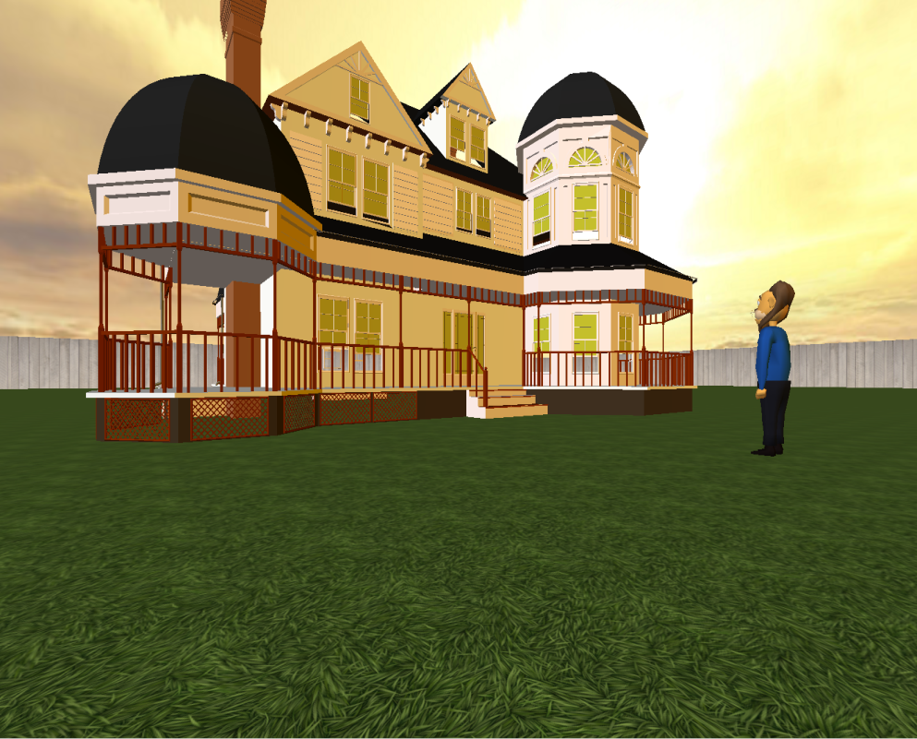

Figure A prototype of the garden area

## Objects

Aside from the static objects such as the walls, ceiling, floors and buildings there are the collectable objects called Antiques and player objects that change the state of the antiques which in turn change the state of the game. For instance the player touches and all of the antiques in the area which completes that area’s state.

### Objects

Each of the areas has one or more target objects (Antiques) that the player has to reach/stretch to collect so it disappears.

* In front of the house:
  + A Key
    - It is on the ground rotating.
    - Only one key in the game, all players are visible and can see the same object.
* The living room:
  + Balloons
    - The balloons are hanging from the ceiling
    - All players have their own items, what other players do with their items is not visible to the others, just the position of the other players is known.
* The aerobic studio
  + Pictures
    - The pictures are hanging from the ceiling.
    - All players have their own items, what other players do with their items is not visible to the others, just the position of the other players is known.
* The back garden:
  + None, this area is for waving and performing the actions to interact. Actions such as giving flowers to players, hugging etc.

### Attributes

Their attributes of the antiques are position, bounding radius, and mesh. The positions of the objects are set systematically at various locations around each area. Each antique attribute has an initial state of “(0,0,0)” , “5cm” and “default.dae”. The final attribute “default.dae” if a placeholder collada model mesh for the visual object and this along with the position will vary from antique to antique.

### States

The states of the objects are binary in the way that they are both alive and static or have been touched and are destroyed, see figure 2 below.

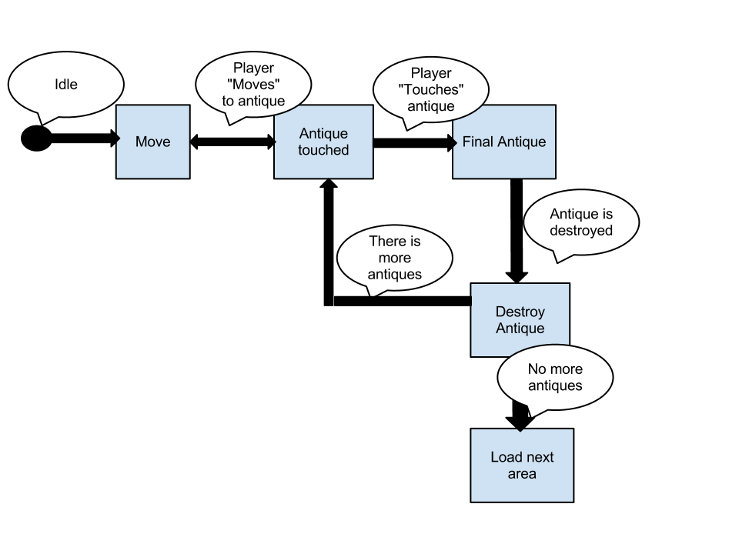

Figure Example area state

By logging on and looking at the game this won’t be particularly apparent, especially for senior users that have never used a PC before. To cater for this situation there will be a video presentation/Demo of the game before each area to explain how one can change the state of the “Antique” objects and also explain the reward system and how to progress through each level.

## Actions

* Walk
* Turn
* Touch
* Hug
* Wave
* Give

These actions apply to not only the virtual user but also to the physical user in real life. By using the Kinect as the input device there is a 1:1 movement ratio needed to control the on screen avatar/model of the player; thus we are assuming that the physical abilities of the user playing will be that they can perform aerobic exercises comfortably.

Walk and turn are mobility actions that act on the player. Touch acts on the collectable objects and the rest can be performed solo or with another player.

## Rules

The players are expected to perform different tasks in each area that requires some form of aerobic stretching. In most areas the users are asked to collect items that are strategically placed so that the user is required to stretch to get it. They are shown how to do this by a demonstration video before each area begins which shows them how to stretch safely and inform them of what is required to complete the area.

The height of the objects are adjusted over time to make it easier and after a certain amount of time the area completes automatically and moves onto the next area.

### Risks

With any exercising there is a risk of over exertion or hyper extending your muscles. It will be explained in the entry into each area the risks and how to play the game and inform them that the game will adapt so over extending isn’t necessary.

There is also a risk of falling or stumbling for senior players so it will be advised that if you are a person likely to fall or be injured by falling to take it easy and maybe use a standing aid that will not affect the Kinect.

### Rewards

In each area there are different ways of achieving a reward of flowers. Flowers can then be given to other players to motivate them and also congratulate them in their effort to complete the session.

You are rewarded by doing the following:

* Outside
  + Hugging
  + Waving
  + Getting the Key
* Living Room
  + Collecting Balloons ( more flowers the faster the spit time between balloons)
* Aerobics studio
  + Collecting pictures ( more flowers the faster the spit time between pictures)
* Overall
  + Group score for total combined time.
  + Individual score for finding hidden items( Randomized in some objects )

## Skills

The players must be able to control their movements and to follow the movements and instructions from an NPC or video / cut scene.

The players must be able to stretch, step, bend and balance.

The players must be able to recognize or be able to see items and stretch for them.

The exercises are real.

## Chance

### Randomness

The locations of the items in each of the areas are random each time a session is started and also the team members can be chosen so the individuals act differently. In the house areas there are sometimes a random surprise item when you touch an item. This increases the group score and the individual’s flower total.

### Interesting risks

The interesting risks are pushing your body to get a greater score for the good of the team. The faster you stretch the better the score of both the group and the user. You also decide which user you give flowers too which ploughs the effort back into the game.

# User Stories

## To play with other players at the same time

### Conditions of satisfaction

* I can see the other players’ avatars.
* I can see their position throughout the game.
* I can see their avatar.

### Storyboard

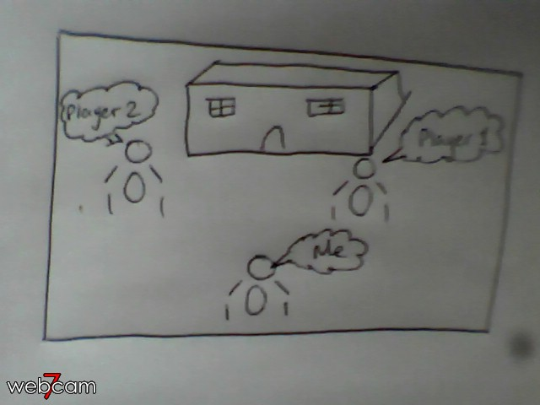

### Changes/Ideas

## 2. To be able to walk on the spot and my avatar walks at the same speed on screen

### Conditions of satisfaction

* The Kinect detects my knees.
* When I lift my knees up and down the game recognises that as a walk movement.
* When a walk movement is performed my avatar moves forward.

### Storyboard

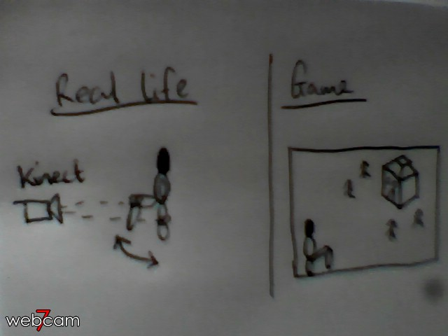

### Changes/Ideas

## To be able to turn using my hands

### Conditions of satisfaction

* Making a pose with my left hand makes my avatar rotate left.
* Making a pose with my right hand makes my avatar rotate right.

### Storyboard

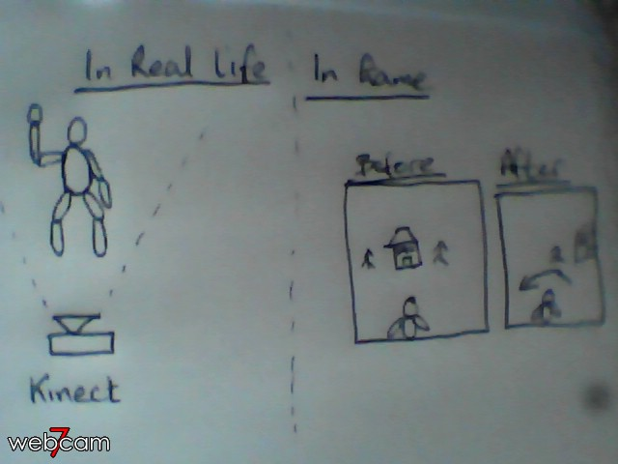

### Changes/Ideas

## 4. To see what my progress in the level is.

### Conditions of satisfaction

* A progress bar is displayed.
* The progress bar is filled by collecting objects.
* When the bar is full the level is over.

### Storyboard

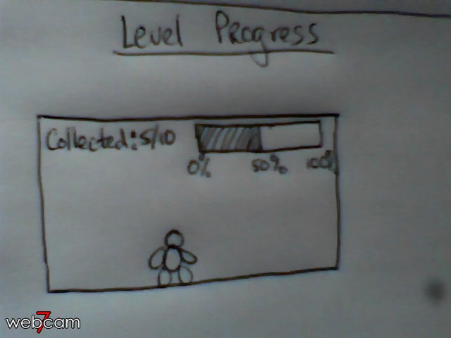

### Changes/Ideas

## To be able to see what my score is on screen.

### Conditions of satisfaction

* Text is displayed on screen showing score.
* When I collect an object my score increments.
* When I perform tasks my score is increased.

### Storyboard

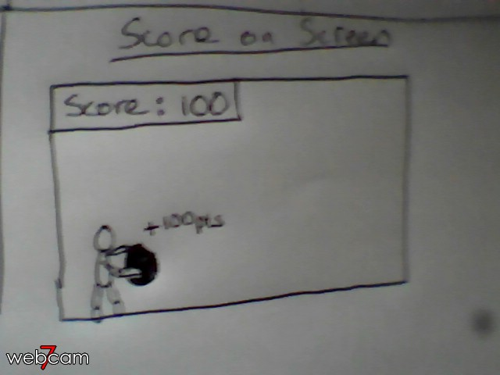

### Changes/Ideas

## 6. To know what to do at the start of each level and how exactly I complete the tasks.

### Conditions of satisfaction

* At the start of each level a video tutorial is played.
* In the tutorial, all of the information I need to complete my tasks is described to me.
* I am able to test out the movements before the game starts and I must complete them within a timeframe or the tutorial starts again.
* The Kinect detects my movements.

### Storyboard

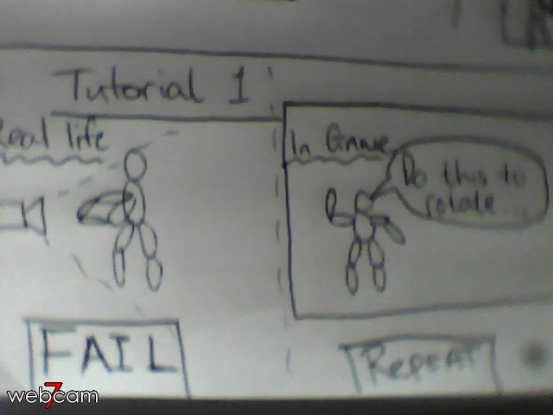

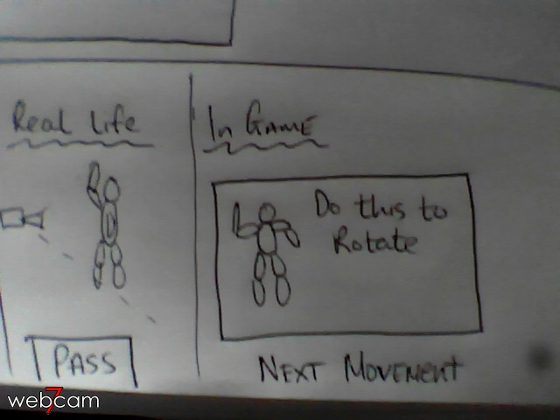

### Changes/Ideas

## 7. To be able to wave to other players.

### Conditions of satisfaction

* When I raise my hand my avatar raises its hand too
* When I wave my hand side to side my avatar’s hand also waves sided to side
* The Kinect detects my hands

### Storyboard

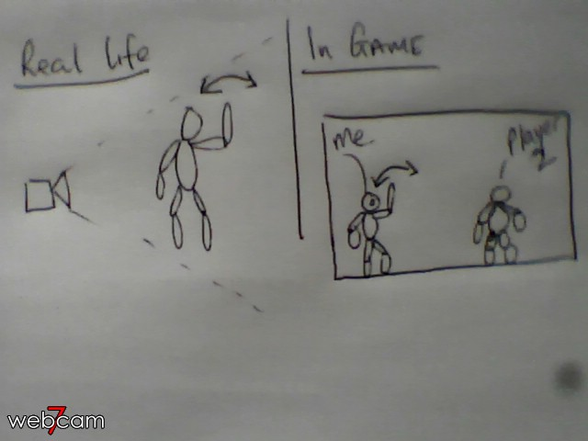

### Changes/Ideas

## 8. To be able to hug other players

### Conditions of satisfaction

* The Kinect detects my arms/Hands.
* When my arms are outstretched and enclosed the system recognises that as a hug pose.

### Storyboard

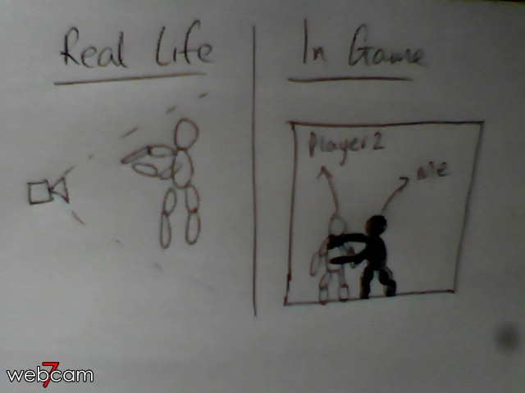

### Changes/Ideas

## 9. To get rewarded for completing tasks

### Conditions of satisfaction

* When I complete a task assigned at the start of the game my score increments.
* I can visually see my score being incremented on screen.

### Storyboard



### Changes/Ideas

## 10. To select from a list of players to play with.

### Conditions of satisfaction

* I see a list of players online.
* I can send an invitation to each player to join a game.
* I can choose to begin the game.

### Storyboard

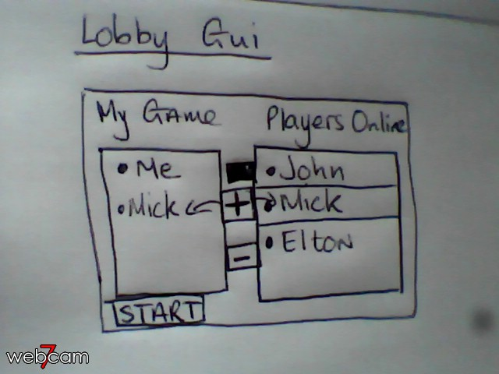

### Changes/Ideas

## 11. To be able to reward my teammates with flowers/xp

### Conditions of satisfaction

* In the final level I can approach my teammate .
* I can perform a movement that the system realises is a give flowers/score pose.
* My flowers/score total decrements.
* The teammate’s flowers/score total increments.
* Audio feedback is played upon completion of the give flowers/score pose.

### Storyboard

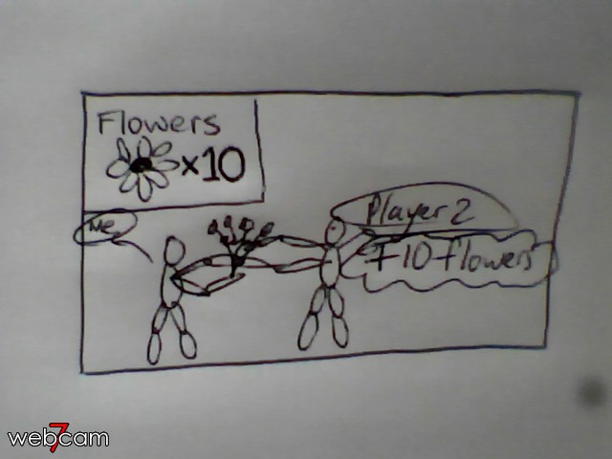

### Changes/Ideas

## 12. To be able to see the group’s score on screen

### Conditions of satisfaction

* Text is displayed on screen detailing the group’s score.
* Upon me or a teammate completing a task the group score is incremented.
* The new score is displayed.

### Storyboard

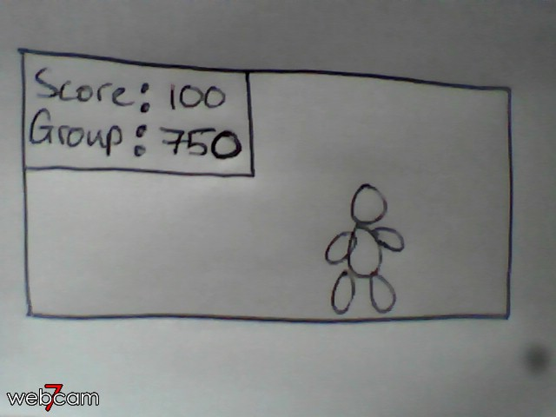

### Changes/Ideas

## 13. To be able to touch objects

### Conditions of satisfaction

* I can see the object on screen
* I can approach the object.
* The Kinect recognises my hands.
* When I move my hands the avatar’s hands move too.
* When my avatar’s hands touch the object I hear/see feedback.

### Storyboard

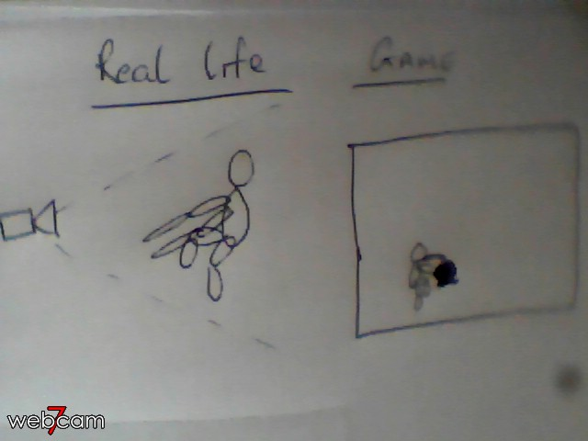

### Changes/Ideas

## 14. To be able to reach all of the objects.

### Conditions of satisfaction

* When the player is within a distance of the object, and is trying to reach, the reach is recorded.
* If the player reaches a certain amount of times unsuccessfully, the object’s height is decremented.
* The player can now reach the object.

### Storyboard

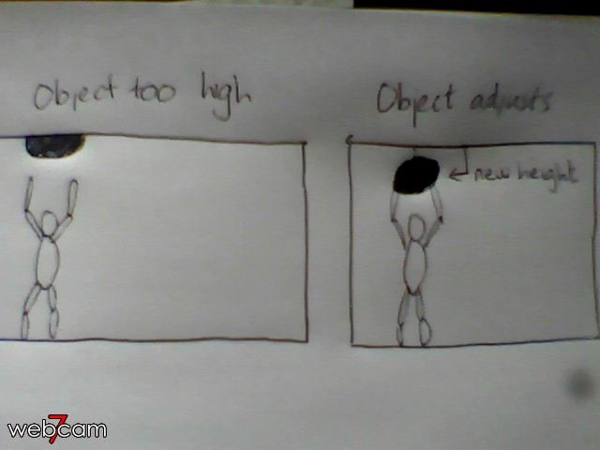

### Changes/Ideas

## See my avatar move the same time I move.

### Conditions of satisfaction

* The Kinect gets the players joints successfully and stores them as “Data”.
* Data is then streamed to a local game server
* The game can get that data at anytime
* The game displays the data on screen in the form of an avatar
* The movement is synchronous on screen with the player.

### Storyboard

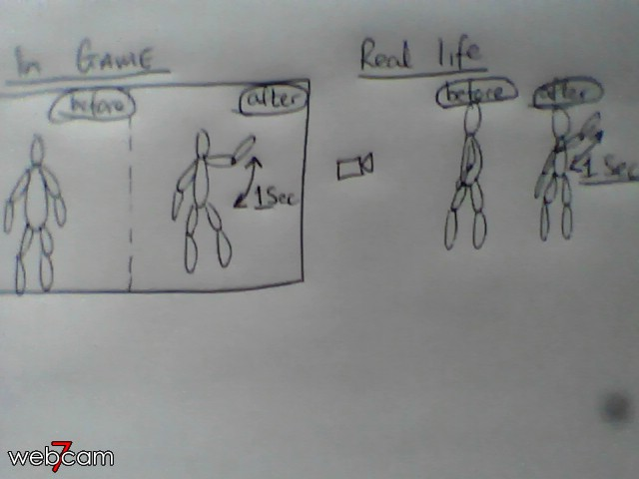

### Changes/Ideas

## The transition between levels to be gradual

### Conditions of satisfaction

* One level finishes and data is displayed for a few seconds
* A screen informing you should appear and tell me that a level change is coming and what level.
* The new level loads

### Storyboard

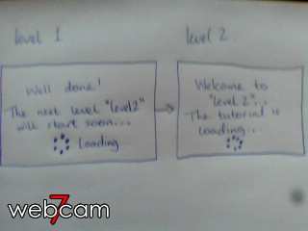

### Changes/Ideas

## To have a definitive end to the game.

### Conditions of satisfaction

* After the last level is finished I get feedback that the game is over.
* After 10 seconds I am returned to the lobby.

### Storyboard

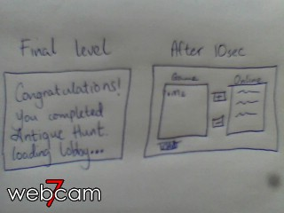

### Changes/Ideas

## For the team to progress to the next level if the final goal is reached by a single member.

### Conditions of satisfaction

* When a player reaches the goal/End of a level every member receives feedback that the goal was reached.
* The next level transition happens even if all team members aren’t at the goal.

### Storyboard

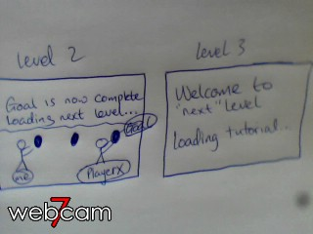

### Changes/Ideas

## In the reach level, there is a hidden item to be found.

### Conditions of satisfaction

* Each time the reach/stretch level is played there will be a random position for a hidden Item.
* The item can only be found by one team member
* At the end of the level all members find out who found the hidden item.

### Storyboard

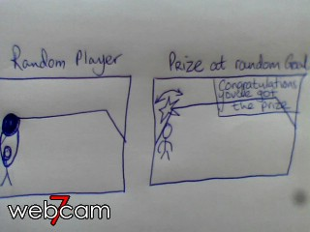

### Changes/Ideas

## A level where I can pick up items from the floor.

### Conditions of satisfaction

* A level is generated where the objects are at floor level.
* The team picks items from the floor.
* When a member reaches the final object the level is finished.

### Storyboard

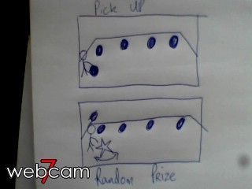

### Changes/Ideas

## My points to be transferred across the levels.

### Conditions of satisfaction

* At the beginning of each game the score is zero.
* At the end of each game the score is the accumulation of all the level’s score.

### Storyboard

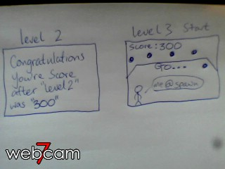

### Changes/Ideas

## Want to see pictures of all my teammates on screen.

### Conditions of satisfaction

* Each member can see the uploaded picture of their current teammates.
* The images will not interfere with the game experience or be in the way.

### Storyboard

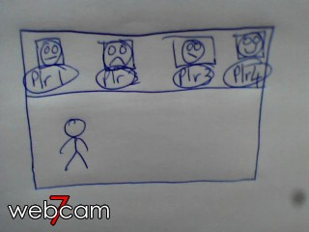

### Changes/Ideas

## After the final level we want to see all the items we collected during the game.

### Conditions of satisfaction

* In the final scene the objects I collected are displayed.
* In the final scene I can see the objects the other teammates have collected.
* The objects are non-collidable or touchable

### Storyboard

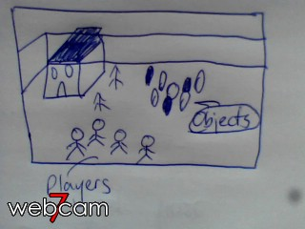

### Changes/Ideas

## (AH-35) Kinect SDK migration

### Conditions of Satisfaction

* The installation process to be simple
* The data output is in vector form
* The data can be streamed via web sockets
* The data is received in the browser

### Storyboard

### Changes/Ideas

* Figure out c# web sockets library. Have a look at [fleck](https://github.com/statianzo/Fleck).
* Research the Kinect SDK, joint data in particular. The data is vectors of length 1.
* Serialization to JSON in C#. Are there existing libraries or do I roll my own.

# Changes

## Change the wallpaper in the reach level.

The wallpaper in the reach level will need to be changed to something more neutral.

## Use time since last frame to update the walking movement.

At the minute the player is moving regardless of the change in time. A further optimization will be that the movement is directly related to frames per second.

## Increase the walking movement.

The walking movement was too slow and the scene was too big to explore with the current speed. The speed will be increased and tested to make sure that the users can move quickly around the scene so that the focus is on one exercise.

## Zoom the camera out from the player to see more of the scene.

The over the shoulder camera angle is a little too close to the player and blocks some of the scene. A fix will be to move the camera back further.

## Pop ups to explain the level and how to interact with the game.

The users in test didn’t know automatically what the game was about and didn’t have any idea of what to do to interact with the game. They had to be told how to rotate, walk, reach and touch objects; as well as how to progress to the next levels. A fix will be a video introduction at the beginning of the game and a tutorial video at the start of each of the levels stating clearly what needs to be done.